American Legion Department of Montana
Fall Conference 2024 Leadership Dinner Reception
October 25, 2024

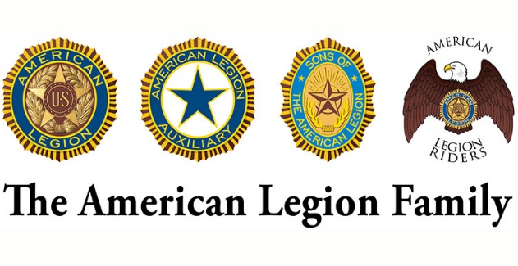
Mark all that apply
Riders
SAL
Riders
SAL
ALA
ALA
Legion
Legion
Friday Evening there will be a joint leadership reception at Hardware Café in Montana City co-hosted by the Department Commander, Auxiliary President, Detachment Commander and Legion Riders Director.

Leadership Reception ………………………………………………………. $35 X _____ = $________
Total $ ________

Registrations must be received by October 15, 2024

Questions
Erin Carpenter – Office Manager
C# 406-324-3989
amlegmtsec@gmail.com

Send Registration Form & Payment To
American Legion of Montana
PO Box 155
Fort Harrison, MT 59636
Name(s) ___________________________________________
__________________________________________________
Address ____________________________________________
City ___________________ State __________ZIP __________ Phone ___________

