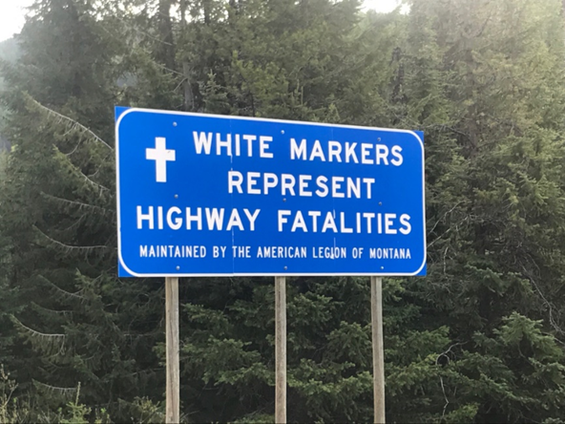
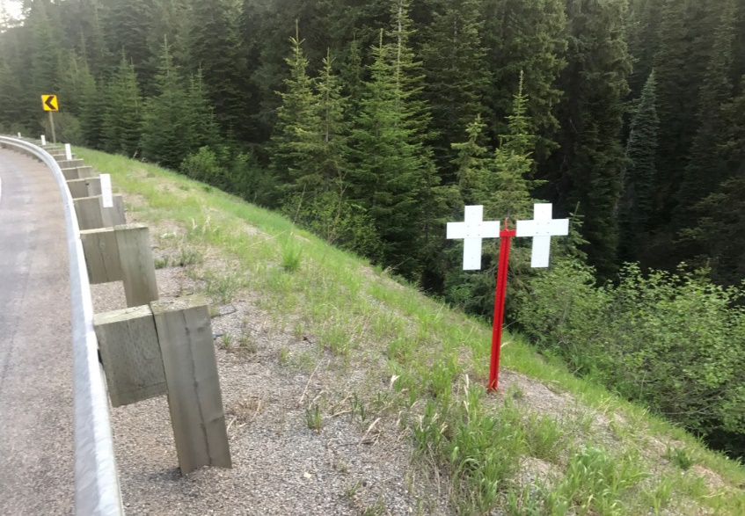

GUIDE TO STANDARDIZED MARKER HARDWARE

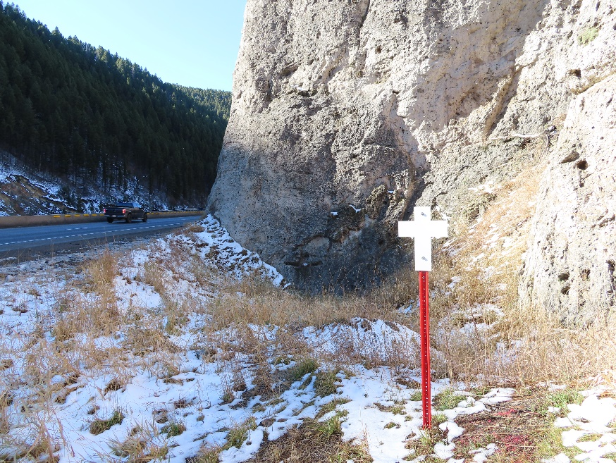

PREFACE

Readers are cautioned that roadside safety policy, criteria, and technology is a rapidly changing field of study. Changes in the roadside safety field are on-going and subject to change after the date of this memo.

Our American Legion Fatality Marker Program has operated under policies and procedures that have been in place for many years.

As time has evolved, so have guidelines under which the program operates. In the early 1950’s a verbal agreement between the Montana Highway Commission and the American
Legion was enough to initiate what was called the “White Cross Program” In 1953 the State of Montana officially adopted the program.

With the advent of the Interstate Highway System, the US Bureau of Public Roads prohibited the location of the White Crosses on Interstate Right-of-Way. It was not until November 2001 that a formal Letter of Instruction was issued by the Montana Department of Transportation (MDT), giving further definition to the program.

In 2007 additional guidance was issued by MDT which specified no advertising; no reflect paint or other devices; and no wreathes or decorations placed upon the crosses. Further stipulated was there shall not be any MDT involvement in providing materials, installation, or maintenance. Guidelines for materials to be used, installation, and location were outlined.

I found, asking anyone a question dealing with authorized materials, installation, etc. usually results in a different answer each time. To update my understanding of the program, I reviewed several tiers of federal and state rules and regulations and visited with design engineers and MDT state leadership. This document, approved by MDT, is designed to provide background information as well as current or updated information for the benefit of the program.

The American Legion Fatality Marker Program success depends entirely on active participation and volunteerism. Our organization belongs to the people it serves and the communities in which it thrives.

Jim Kelly, Chairman
American Legion
Fatality Marker Program

GUIDE TO STANDARDIZED MARKER HARDWARE
(Changes or points of emphasis in specifications are in BOLD print)

Montana Department of Transportation (MDT) has a written policy for designing roadsides that incorporates wide clear zones, and breakaway sign and support structures in new construction and reconstruction. Montana Department of the American Legion operates the Fatality Marker Program under these established policies.

GENERAL
The white markers, together with the upright supporting post, are to be furnished by the local American Legion Posts and installed by them. American Legion Posts may make the markers themselves. There should be no decorating or writing of any kind on the markers. It is recommended any decorations attached to the highway fatality markers be removed during regular maintenance.

A small American Legion emblem, small label, etching or “dog tag” may be placed on the back of the marker to let people know who erected it. It shall be the duty of the Legion Post most closely situated to the scene of the crash to furnish the marker and see that it is properly placed and maintained if it is in that Post's area of responsibility.

Marker specifications:
- They should be made of 1/8 or 3/16-inch-thick band steel or aluminum

- The recommended width of the metal is four inches (4").

- The crossbar should be twelve inches (12") across, and the upright portion of the marker should be sixteen inches (16”) inches. If less than 4" wide metal is used the dimensions of the marker may be reduced accordingly to a minimum of 9" x 12".

- The markers should be seam welded to prevent rusting but may be riveted or bolted together.

- Front and back of white markers are to be painted with bright white exterior metal paint. They shall NOT be constructed of or painted with reflective material.

Support specifications:
- Supporting upright post shall be steel “U” delineator post rated at 1.12 ppf (minimum) to 2.0 ppf (maximum), six foot in length.
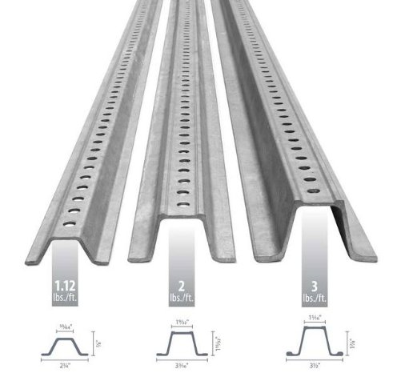
- Supporting post should be pounded into the ground a minimum of 18". NOTE: Be very aware of unground utilities – look for underground pipe or cable markers in all directions. Montana one-call (800-424-5555) should be contacted a week before installation to confirm absence of utility conflicts.

- Top of supporting post and markers should not exceed 54” above the ground. NOTE: MDT recommends using 6' posts as it will provide a uniform mounting height of 54” and a uniform depth of 18".

- Supporting posts mounted in concrete require a breakaway joint.

- Supporting posts are to be painted bright red with exterior metal paint. They shall NOT be constructed of or painted with reflective material.

Break-away Signposts

Break-away signpost regulations were revised in 2013. The change was due to the fact rigid objects were dangerously close to roadways, causing hazardous situations if struck by a vehicle. Supports for road signs need a redesign, ensuring easier breakaway. Upon impact, they must break away or yield.

Even small signs can still be a threat. The Manual on Uniform Traffic Control Devices (MUTCD) which is the law, states specifically, in Section 2A-19: "... Ground mounted sign supports shall be breakaway, yielding, or shielded with a longitudinal barrier or crash cushion if within the clear zone."

This stated requirement is applicable to all roads, public or private. Non-breakaway signs must be replaced to adhere to the new rule.

Installation:
- Fatality Markers shall be placed in the right-of-way in the direction of travel prior to crash (i.e., westbound travel = westbound right-of-way, northbound travel = northbound right-of-way).

- Fatality Markers shall be placed perpendicular (not parallel) to the highway. (Note position of Marker attached to “U” shaped post.)
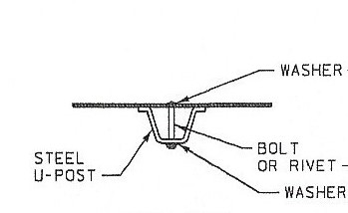
- Fatality Markers shall not present a vertical or horizontal obstacle for pedestrians along bike or pedestrian pathways.

- Fatality Markers shall be outside of CLEAR ZONE
  - State & local highways (6’ behind a guardrail or 30’ from edge of roadway)
  - Four lane roadways (6’ behind a guardrail or 50’ from edge of roadway-when feasible)
  - OR Outside edge of “MOW” areas

- Only one support post per fatality location is allowed. In the event of multiple fatalities at same accident scene, multiple white markers may be used on a single support post.

- DO NOT install markers in median and DO NOT attach marker to guard rail support.

- Fatality Markers currently in place are "Grandfathered" and do not need to be removed or corrected to conform to these standards.

Maintenance:
- Fatality Markers placed on the highways of Montana are to be maintained annually by the respective Legion Posts. This can be as simple as replacing a supporting post / marker that has been refurbished or painting. This work should be done in the Spring, prior to Memorial Day.

- Markers will be removed under three circumstances:
  - If a family requests the removal of a sign, it will be expeditiously removed
  - If a sign is no longer in satisfactory condition due to wear and/or appearance
  - When a section of highway is reconstructed to new standards, all markers that involve the old roadway shall be taken down regardless of condition.

- Removed markers will not be replaced unless requested by a family member.

- When Fatality Markers are required to be removed and reset for any reason, the Legion Post responsible is to re-erect the marker at the appropriate location with breakaway, lateral clearances and mounting heights as required by this document.

- Legion workers on or near the roadway shall wear high-visibility safety clothing.

New or Re-Construction:
- In the event a section of highway is undergoing design changes, all fatality markers should be removed by the local Legion Post and not be replaced.

- If the highway is only being re-surfaced or having the shoulders improved, all markers should be replaced using these updated requirements upon completion of the re-construction.

- Installing guardrails, installation of underground cables, or moving the tree line back may require the fatality markers to be removed and be replaced.

IDEAS:

- New breakaway/yielding and crashproof post specifications allow for markers to be easily disassemble and a new supporting post or marker put in place, avoiding total replacement of post and/or welding. Markers can be attached to the support post after it is in the ground.

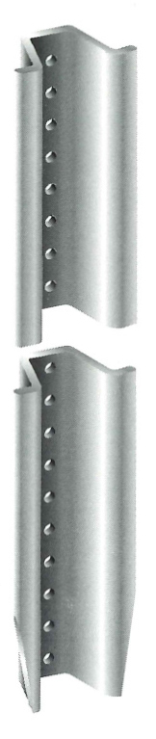
“U Channel Signposts” are manufactured from high quality, high tensile rail steel and finished with a protective coating of weather resistant baked enamel paint or galvanized by hot dipping per ASTM A123.
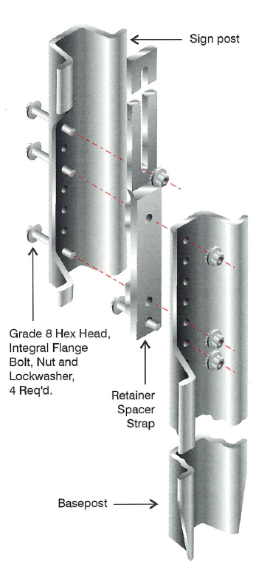
Break – Away design permits quick and easy installations from ground level with simple tools. The base posts are readily driven 16” into hard soils, or placed in concrete, leaving 8” above ground. A top post is then attached to the base with four bolts. When impacted, base posts, top posts and sign panels are often reusable. Even if damaged, top posts can often be cut into base posts.

- We have been successful in contacting highway construction companies and having them donate “used” delineator posts which cannot be reused on other road projects. We also contacted a local highway sign company, and they donated the pre-painted aluminum materials for the Markers. We give them a tax credit for their donation.

- Some local machine shops or Industrial Arts classes will donate either the material or workmanship to construct the marker.

- A cooperative agreement with a local government agency to purchase required posts at a discount. To avoid a conflict of interest, local Legion Post must pay for posts.

- If you must purchase material, pre-drilled, breakaway/crashproof U-shaped steel posts are available at most hardware stores. They may also be available in other ranch or fencing establishments near you. If the post and marker is pre-drilled, the marker can be attached to the post after it is in the ground. An engineer explained to me, it is the holes that make it breakaway, yielding, or crash proof.

- Keep a few support post/markers in reserve. Refurbish them during the winter months. During annual maintenance, it may be quicker to replace a damaged support/marker with a new/refurbished marker built to standards. Reduces field maintenance.

FREQUENT QUESTIONS AND ANSWERS:

Must We Seek Permission to Install Fatality Markers?
During initial discussions back in 1952, the perception was the American Legion agreed to place “White Crosses” (Fatality Markers) at the scene of every fatal accident on Montana highways. Knowing many of the fatalities may involve “out-of-state” persons, there was no provision to notify family members for permission to install a Marker. In fact, provisions were made for the immediate removal of any Fatality Marker upon request of a family member.

Is There a Time Limit for Installing a Marker?
No. If the fatal crash happened prior to the start of the program (1953), this decision is left to the local Post. If the fatality has been since 1953; or the family makes the request, and has an accident report or some documentation, install the requested Marker

Are Fatality Markers Memorials?
No! American Legion Fatality Markers mark the scene of a fatal accident and serve as part of a Highway Safety Program. They are placed to serve as a reminder to drive carefully and alert drivers to potential hazard areas.

Can Markers Be Decorated?
Most Legion members realize a family has lost a mother, father, brother, sister, or close relative and are sensitive to the trauma surrounding death and the need to grieve.

Decorating a newly installed marker may be reasonable but the use of any type of decoration obstructing the marker is strongly discouraged, as this reduces visibility and defeats the purpose of this highway safety program.

American Legion Fatality Markers are routinely maintained, and decorations are removed. If redecorated, the marker may be removed.

May Families Install Private Memorials in the Right-of-Way?
This practice is not allowed and is discouraged. Montana Department of Transportation (MDT) has informed the American Legion Fatality Marker program that such displays may be removed. The American Legion is not responsible for removal of such displays.

Can Fatality Markers Be Placed Along the Interstate?
Yes, you can put American Legion Fatality Marker up on the Interstate in Montana. (SEE: CLEAR ZONE)

Why Does the American Legion Fatality Marker Program Use the White Cross Symbol?

A civil right group filed suit against the state of Montana, and eventually against the American Legion over the use of the “White Cross” symbol.

It was determined a “Cross” isn’t just a Christian symbol. For instance, on military maps, the symbol may represent a hospital or even a graveyard; at one time it was considered a pagan symbol of fertility; to others, use of the cross was considered a subversive act. There are individuals who wear cross necklaces because of the beautiful and simple design, they wear cross jewelry for fashion not to make a religious statement. Some state buildings use the “cross” in their architecture.

Fatality Markers, or a “White Cross” marks the scene of a fatal motor vehicle crash and serve as part of a Highway Safety Program. They are installed to serve as a reminder to drive carefully and alert drivers to potential hazard areas.

Yes, some of us old timers, and even leadership, still slip and refer to the program as the White Cross program, because of the lawsuit and a decision by the state we now emphasize the Fatality Marker Program.

Glossary

American Legion - American Legion was chartered by Congress in 1919 as a patriotic veteran’s organization. Focusing on service to veterans, servicemembers and communities, the Legion evolved from a group of war-weary veterans of World War I into one of the most influential nonprofit groups in the United States.

Breakaway - A design feature which allows a device such as a sign support to yield or separate upon impact.

Clear Zone - The unobstructed, traversable area provided beyond the edge of the through traveled way for the recovery of errant vehicles. The clear zone includes shoulders, bike lanes, and auxiliary lanes, except those auxiliary lanes that function like through lanes.

Fatal Crash - A law enforcement-reported crash involving a motor vehicle in transport on a traffic-way in which at least one person dies within 30 days of the crash.

Fatality Marker Program – An American Legion program intended as a highway safety program aimed to reduce deaths resulting from traffic crashes. Markers are placed at the scene of fatal vehicle accidents within the borders of Montana.

Federal Highway Administration (FHWA) - An agency within the U.S. Department of Transportation that supports State and local governments in the design, construction, and maintenance of the Nation’s highway system (Federal Aid Highway Program) and various federally and tribal owned lands (Federal Lands Highway Program).

Manual on Uniform Traffic Control Devices (MUTCD) - A document issued by the Federal Highway Administration (FHWA) of the United States Department of Transportation (USDOT) to specify the standards by which traffic signs, road surface markings, and signals are designed, installed, and used.

Median - The portion of a divided highway separating the traveled ways for traffic in opposite directions.

Montana Department of Transportation (MDT) - Montana Department of Transportation is an agency in the U.S. state of Montana, responsible for numerous programs related to the construction, maintenance, and monitoring of Montana's transportation infrastructure and operations.

National Highway System (NHS) - The National Highway System is a network of strategic highways within the United States, including the Interstate Highway System and other roads serving major airports, ports, rail or truck terminals, railway stations, pipeline terminals and other strategic transport facilities.

Roadside Design Guide (RDG) 4th edition published in October 2011.

Highway Sign - Any traffic control device that is intended to communicate specific information to road users through a word or symbol legend.

Manual on Uniform Traffic Control Devices for Streets and Highways (MUTCD) - Defines the standards used by road managers nationwide to install and maintain traffic control devices on all public streets, highways, bikeways, and private roads open to public travel. The MUTCD is published by the Federal Highway Administration (FHWA)
REFERENCES

AASHTO's Roadside Design Guide and AASHTO's Manual for Assessing Safety Hardware for guidance on selecting the appropriate Test Level (TL) based on traffic using the facility.

These devices have been evaluated in accordance with the NCHRP Report 350 or the 1985 and 1994 AASHTO Standard Specifications for Structural Supports for Highway Signs, Luminaires and Traffic Signals. Note that breakaway support hardware that was determined to be eligible under either the 1985 or 1994 editions of the AASHTO specifications were determined to meet the NCHRP Report 350 testing guidelines. However, additional testing and evaluation may be necessary to meet the current criteria in MASH.

For further information about sign supports, please refer to AASHTO Task Force 13 Guide for Sign Supports, an Online Guide to Sign Support Hardware.

Federal Highway Administration (FHWA) policy requires all roadside appurtenances such as traffic barriers, railings, signs, and work zone hardware used on the National Highway System (NHS) to include Interstates, meet the performance criteria contained in NCHRP Report 350 or MASH.

The mission of FHWA is to enable and empower the strengthening of a world-class highway system that promotes safety, mobility, and economic growth, while enhancing the quality of life of all Americans.

The Manual on Uniform Traffic Control Devices for Streets and Highways, (MUTCD) defines the standards used by road managers nationwide to install and maintain traffic control devices on all public streets, highways, bikeways, and private roads open to public travel. The MUTCD is published by the Federal Highway Administration (FHWA) under 23 Code of Federal Regulations (CFR), Part 655, Subpart F.

The MUTCD, which has been administered by the FHWA since 1971, is a compilation of national standards for all traffic control devices, including road markings, highway signs, and traffic signals. It is updated periodically to accommodate the nation's changing transportation needs and address new safety technologies, traffic control tools, and traffic management techniques.

On December 16, 2009, a final rule adopting the 2009 Edition of the MUTCD was published in the Federal Register with an effective date of January 15, 2010. States must adopt the 2009 National MUTCD as their legal State standard for traffic control devices within two years from the effective date (January 15, 2012).

A sign support can become a deadly hazard when struck by a vehicle that drives onto the roadside; therefore, there is a standard that requires all roadside sign supports in the clear zone to be breakaway, yielding, or shielded by a barrier or crash cushion.

‘Breakaway’ is a term to describe crash tested sign supports that break or bend upon impact. This includes sign supports that, when struck by a vehicle, separate from the base, and are knocked ahead of or up and over the errant vehicle. A ‘yielding’ support refers to a support that bends, allowing a vehicle to run over it.

All sign supports on highways within the clear zone must either be of a breakaway type meeting crashworthiness or be shielded by guardrail, barrier, or an energy absorbing system meeting.
Barriers are typically not installed to shield roadside signs, especially on local roads; hence, the design of the post, regardless of the type, must provide the breakaway or yielding feature.

Breakaway and Crashworthy
Breakaway and crashworthy are interchangeable terms. When the term breakaway is used, it means the sign support is designed so it breaks away or yields safely-even in the case of a steel post.

Breakaway describes all types of sign supports that are designed to yield when impacted by a vehicle.

Crashworthy refers to a roadside sign that has been successfully crash tested in accordance with a national standard.

MDT specifications for our Fatality Marker Program specify a “1.12 ppf steel "U" delineator post” which is both breakaway/yielding and crashworthy. “U” shaped delineator posts up to 3.0 ppf are considered to be yielding

Clear Zone
Clear zones are designed to provide a clear recovery space for many drivers who run off the road. All clear zone distances are measured from the edge of the traveled way (pavement).

Although there are varying factors, Fatality Markers should be place six feet behind a guard rail or outside 30 feet on most state highways. On divided highways the clear zone extends to 50 feet. Common sense also dictates markers should be placed on the outside edge of mowed areas or at the fence line on parallel frontage roads.

U-Channel Steel Post
The U-channel hot rolled steel post is a common small sign support. It is considered breakaway since it will bend, break, or pull out of the ground when it is hit. The post shall be driven into the ground and not encased in concrete.

A U-channel delineator post of re-rolled rail steel weighing 3 pounds-per-foot or less meets breakaway requirements by itself.

Square Steel Tube
Another acceptable signpost is the square steel tube (perforated) design. Posts of this type are considered breakaway if they are 2 ¼ inches or less in size.

RE-BAR SHALL NOT BE USED.

Post Support
Posts should be driven into the ground 18”, not cemented unless installing the breakaway device.

If a sign replacement is warranted, do not assume the original sign was placed correctly. It is important to check the location of the support and the mounting height of the sign above the roadway to ensure the sign is visible and crashworthy.

Placement
Not less than six feet (6’) from highway shoulder of roadway.

Visibility
Is the marker visible, both day and night, at the required distance? Fatality Markers are part of our Highway Safety Program. If blocked by vegetation or other signs it is not effective.

Utilities
WHEN INSTALLING A NEW SIGN CHECK WITH YOUR UTILITY COMPANY AND ANY OTHERS WHO MAY HAVE UNDERGROUND CABLES AND CONDUITS. LOOK FOR WARNING SIGNS. CALL Montana One-call @ 800-424-5555 TO CONFIRM THE ABSENCE OF UTILITY CONFLICTS. DO NOT ASSUME UTILITIES ARE BURIED AT REQUIRED DEPTH.

